EXPERIMENT 14: - Create a Snapshot of a VM and Test it by loading the Previous Version/Cloned VM

Step 1: - Install VM Ware PlayStation

Step 2: - Create new virtual machine

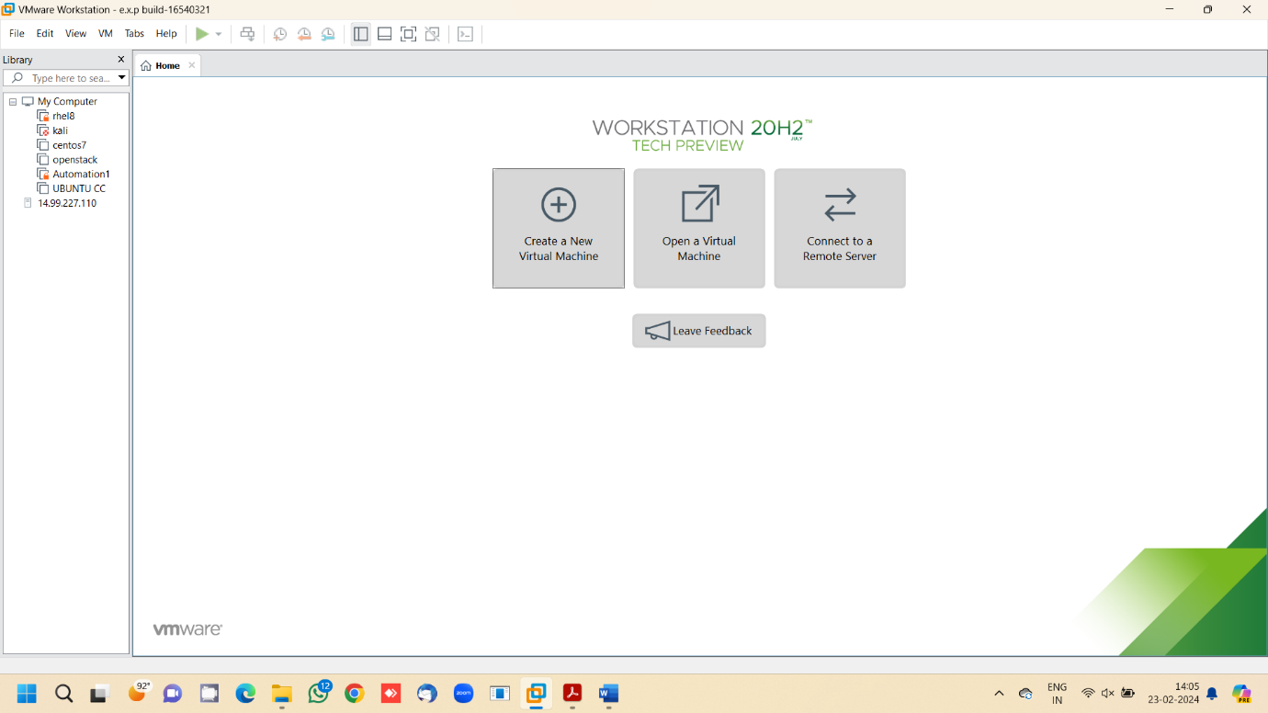

Step 3: - Choose Typical option and click Next

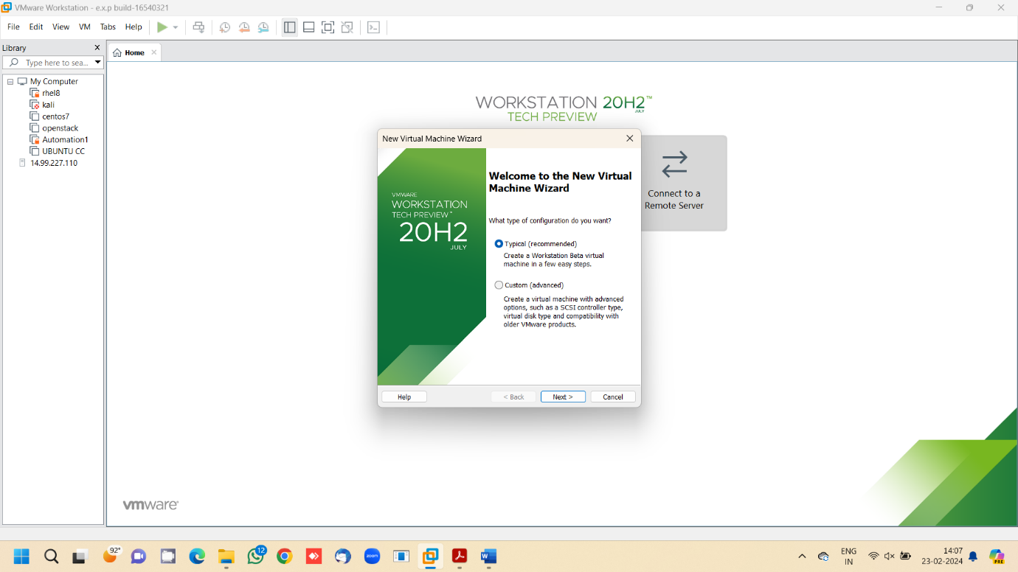

Step 4: - Click on the third option at guest os screen

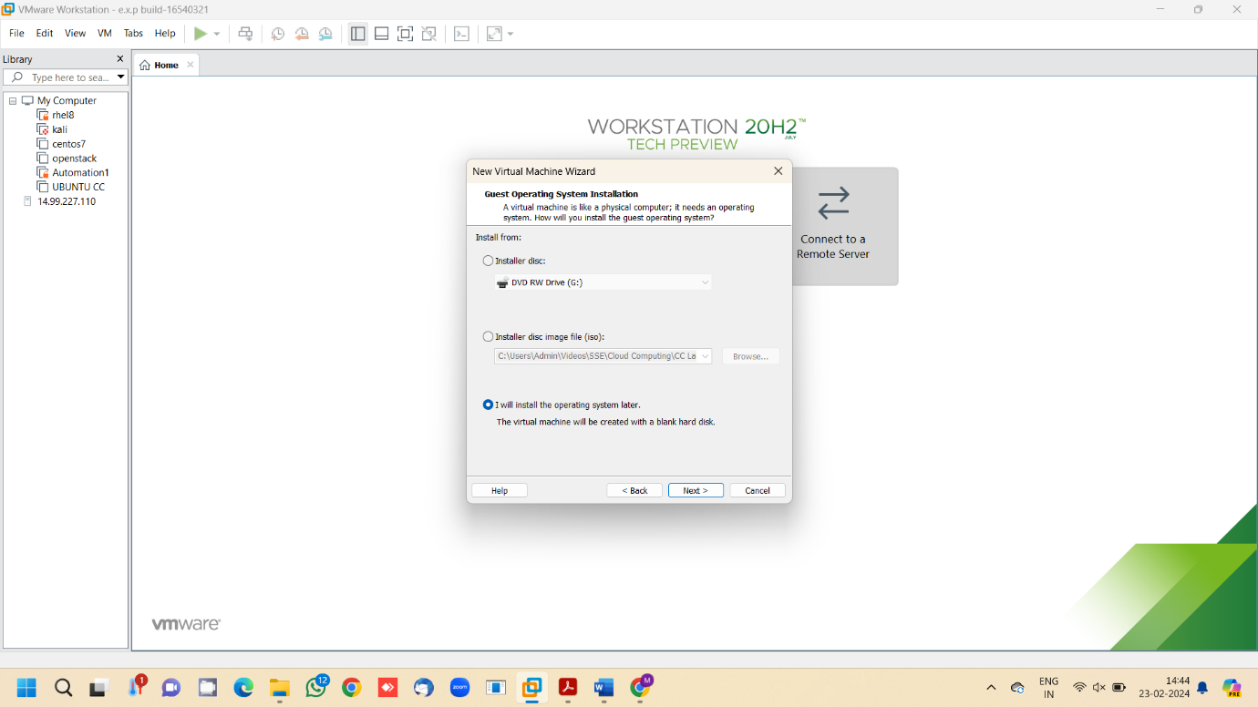

Step 5: - Choose the required os and click next

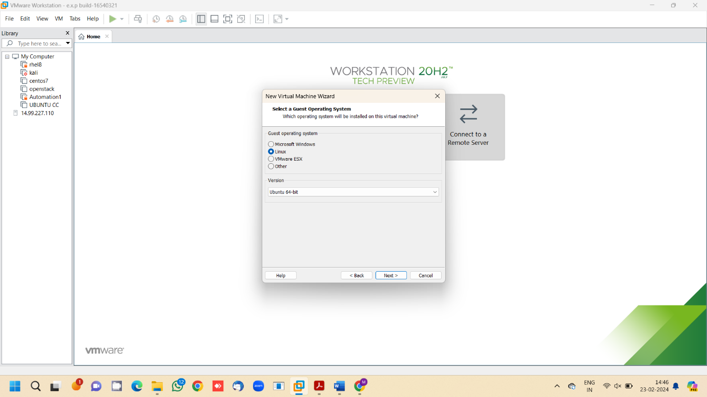

Step 6: - Enter the name of the virtual machine

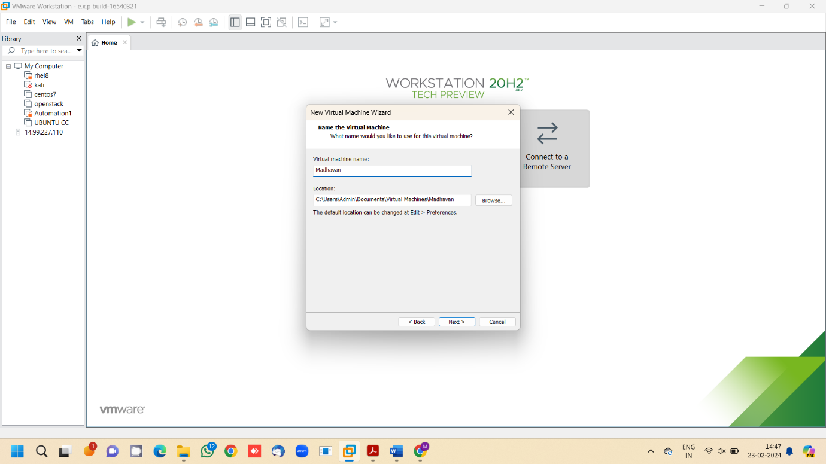

Step 7: - Edit the disk space and click next

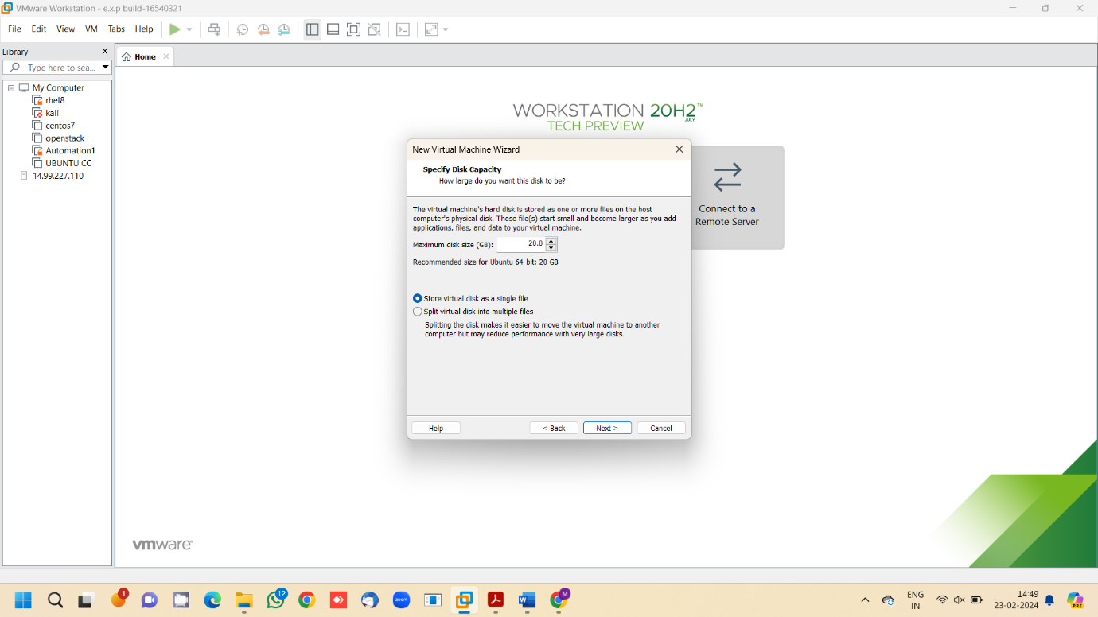

Step 8: - Check the summary and click next

Step 9: - Go to VM, Snapshot, take snapshot, enter the name of the snapshot and click on take snapshot.

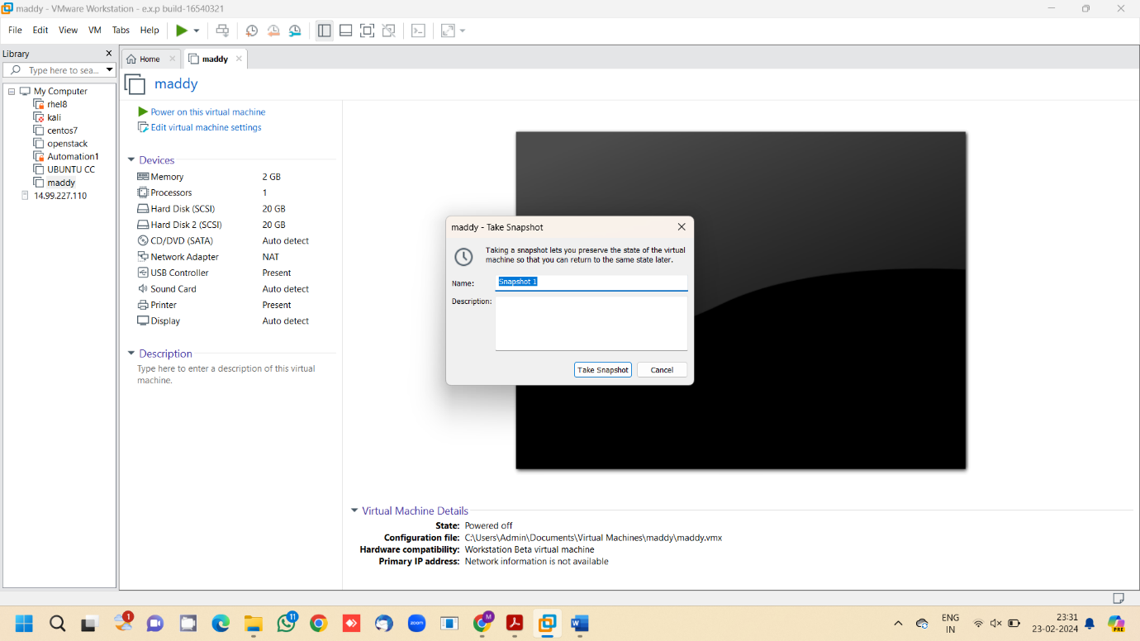

Step 10: - Edit the virtual machine settings after taking a snapshot

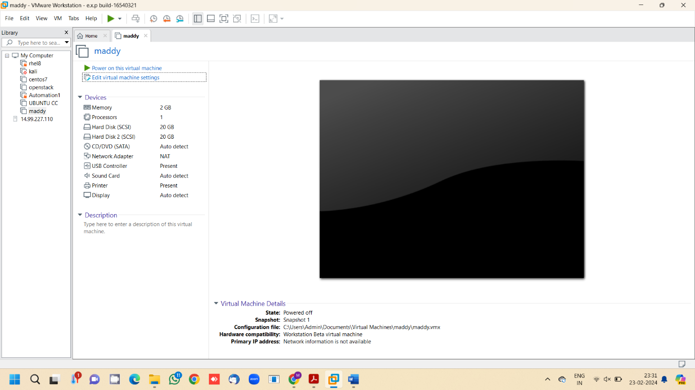

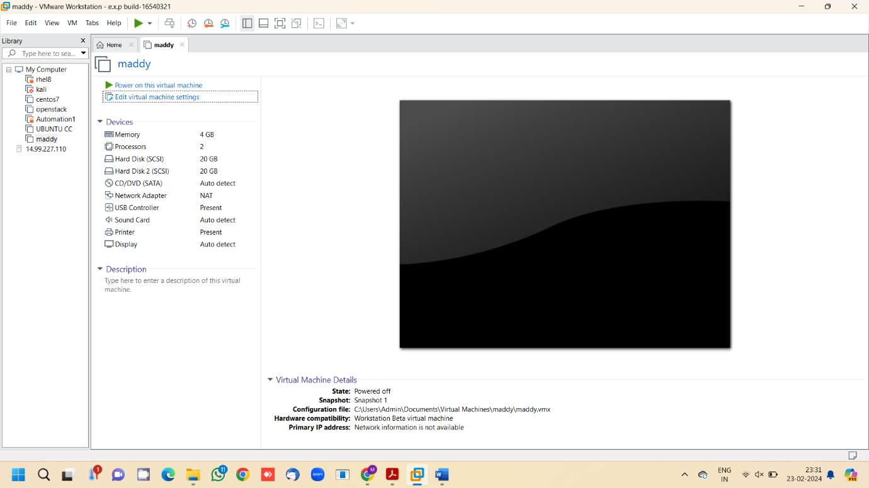

Step 11: - Go to VM, Snapshot, Snapshot Manager

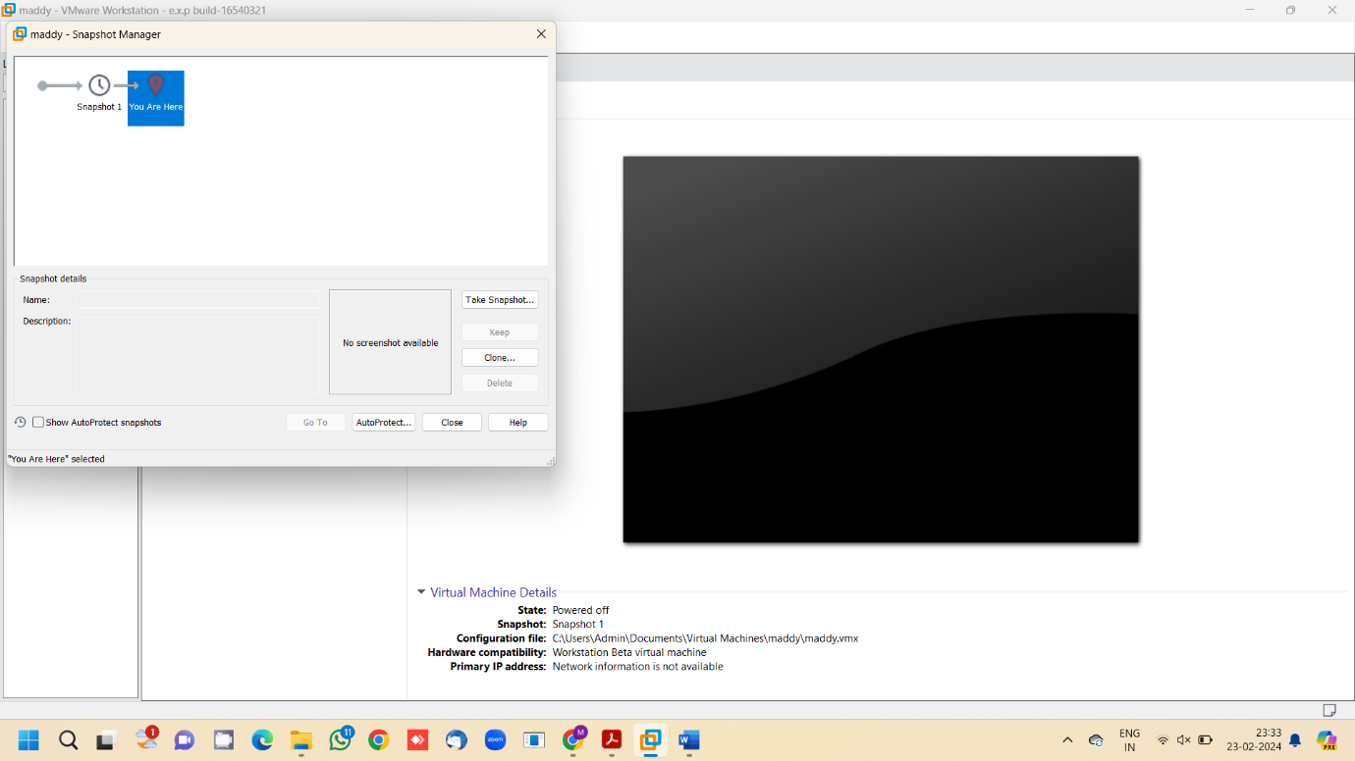

Step 12: - Click on the snapshot 1 and click go to and click yes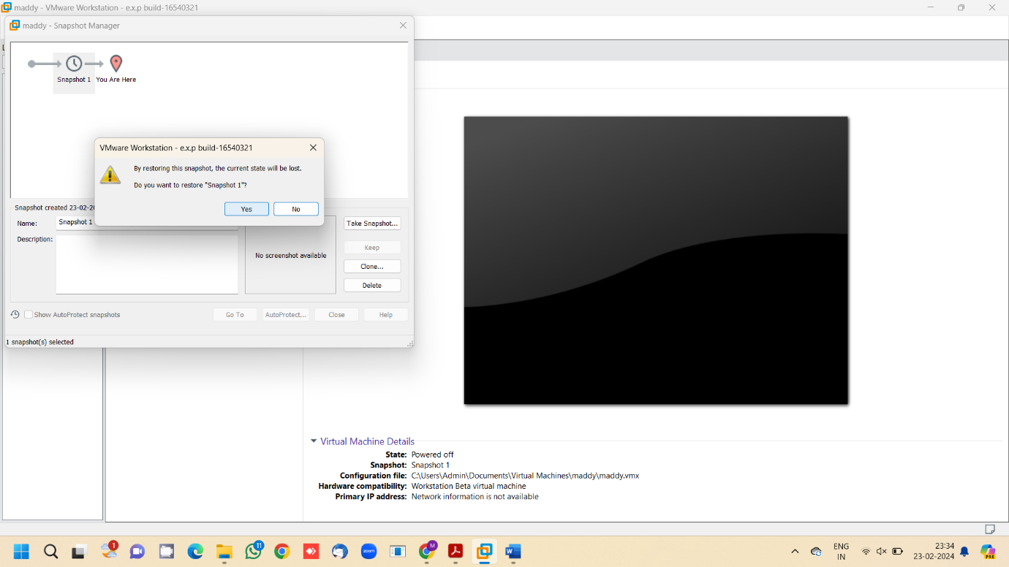

Step 13: - Snapshot was successfully tested

